# Apply machine learning

It is an unsupervised as a machine learning problem.

## Speed_kms Diam_min Moondist_LD_nom  
## 1 8.69 250 3.75  
## 2 10.65 37 15.55  
## 3 5.55 610 8.09  
## 4 3.13 40 12.63  
## 5 4.27 25 6.86  
## 6 10.97 92 19.09

## num [1:1000, 1:2] 0.811 -0.538 3.092 -0.519 -0.614 ...  
## - attr(*, "dimnames")=List of 2  
## ..$ : chr [1:1000] "1" "2" "3" "4" ...  
## ..$ : chr [1:2] "Diam_min" "Moondist_LD_nom"  
## - attr(*, "scaled:center")= Named num [1:2] 121.9 12.5  
## ..- attr(*, "names")= chr [1:2] "Diam_min" "Moondist_LD_nom"  
## - attr(*, "scaled:scale")= Named num [1:2] 157.86 4.73  
## ..- attr(*, "names")= chr [1:2] "Diam_min" "Moondist_LD_nom"

### Method 1: A plot of the total within-groups sums of squares against the

### number of clusters in a K-means solution can be helpful. A bend in the

### graph can suggest the appropriate number of cluster

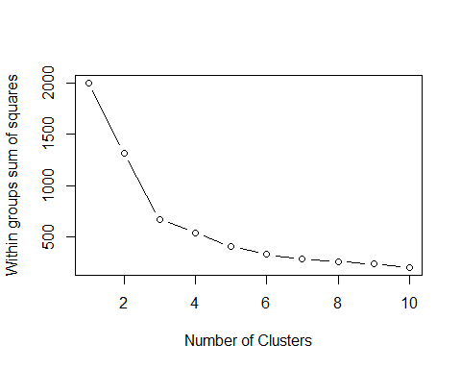

### Barplot sugested 10 clusters and number 3 is the most favorable.

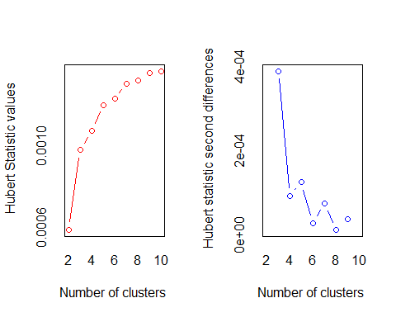

## *** : The Hubert index is a graphical method of determining the number of clusters.  
## In the plot of Hubert index, we seek a significant knee that corresponds to a   
## significant increase of the value of the measure i.e the significant peak in Hubert  
## index second differences plot.   
##

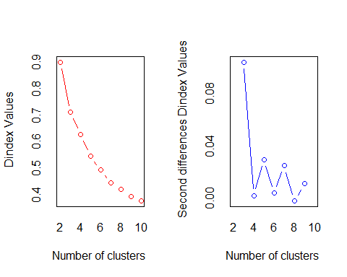

## *** : The D index is a graphical method of determining the number of clusters.   
## In the plot of D index, we seek a significant knee (the significant peak in Dindex  
## second differences plot) that corresponds to a significant increase of the value of  
## the measure.   
##   
## *******************************************************************   
## * Among all indices:   
## * 1 proposed 2 as the best number of clusters   
## * 15 proposed 3 as the best number of clusters   
## * 1 proposed 4 as the best number of clusters   
## * 3 proposed 6 as the best number of clusters   
## * 2 proposed 9 as the best number of clusters   
## * 1 proposed 10 as the best number of clusters   
##   
## ***** Conclusion *****   
##   
## * According to the majority rule, the best number of clusters is 3   
##   
##   
## *******************************************************************

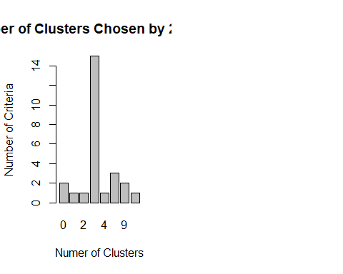 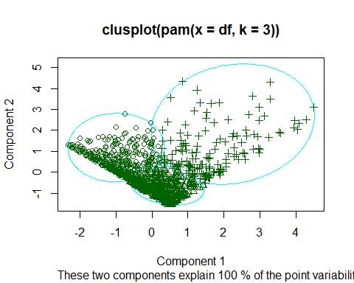

### * Visualize these clusters using function clusplot() from the cluster library

### * Would you consider this a good clustering?